**JAVA 1st Internal**

Answer any five (2*5=10 M)

1. Define internet and WWW.

A means of connecting a computer to any other computer anywhere in the world via dedicated routers and servers **KLE**

The internet is a huge network of computers all connected together. The world wide web (‘www’ or ‘web’ for short) is a collection of webpages found on this network of computers.

1. Differentiate between C and Java.

|  |  |
| --- | --- |
| **C** | **JAVA** |
| C is a Procedural Programming Language. | Java is Object-Oriented language. |
| In C declaration of variables is at the beginning of the block. | We can declare variables  anywhere. |
| C does not supports Threading. | Java supports the concept of  threading. |
| C supports pointers. | Java does not supports pointers. |
| C is platform dependent. | Java is a platform independent. |

1. Write a Java program to demonstrate command line arguments

A) class ComLineEx

{

public static void main (String args[])

{

for(inti=0;i<args,length;i++)

{

System.out.println("Java is : "+args[i]);

}

}

}

Output:

C:\jdk1.8.0_131\bin>javacComLineEx.java

C:\jdk1.8.0_131\bin>java ComLineEx Simple Object-Oriented Robust Secure

Java is : Simple

Java is : Object-Oriented

Java is : Robust

Java is : Secure

1. Definetype casting in Java with an example.

Type Casting is a process of changing one type value to another type. It is known as type casting.

public class Test

{

Public_static_void_main(String[]args)

{

Int i = 100;

long l = i;

float f = l;

System.out.println("Int value "+i);

System.out.println("Long value "+l);

System.out.println("Float value "+f);

}

}

output

1. Write a Java program to demonstrate if-else statement.

classIfStatementExample

{

public static void main(String[] args)

{

int number[] = {50,65,56,71,81};

int even=0,odd=0;

for(int i= 0;i<number.length;i++)

{

if((number[i] % 2)==0)

{

even += 1;

}

else

{

odd += 1;

}

System.out.println(“\n Even Numbers : “ + even + “Odd Numbers : “ +odd);

}

}

output

1. Write a Java Program to demonstrate While loop.

Import Java.io.*;

class WhileLoop

{

public static void main(String args[])

{

inti=1;

while(i<=10)

{

System.out.print("\n\tI= "+i);

i++;

}

}

}

output

Answer any Four (5*4=20 M)

1.List and explain 5 features of java?

## Simple

Java is very easy to learn, and its syntax is simple, clean and easy to understand

## Object-oriented

Java is an Object-oriented programming language. Everything in Java is an object.

## Platform Independent

Java code can be run on multiple platforms, for example, Windows, Linux, Sun Solaris, Mac/OS, etc.

## Robust

• Java is robust because:

* It uses strong memory management.
* There is a lack of pointers that avoids security problems.

## Secured

• Java is best known for its security. With Java, we can develop virusfree systems. Java is secured because:

**Distributed**

Java is distributed because it facilitates users to create distributed applications in Java.

**Multi-threaded**

A thread is like a separate program, executing concurrently. The main advantage of multi-threading is that it doesn't occupy memory for each thread.

**Portable**

Java is portable because it facilitates you to carry the Java bytecode to any platform.

Interpreted

Typical Java environment consists of two programs: Java compiler and Java Virtual Machine.

1. List and explain different data types in java with diagram

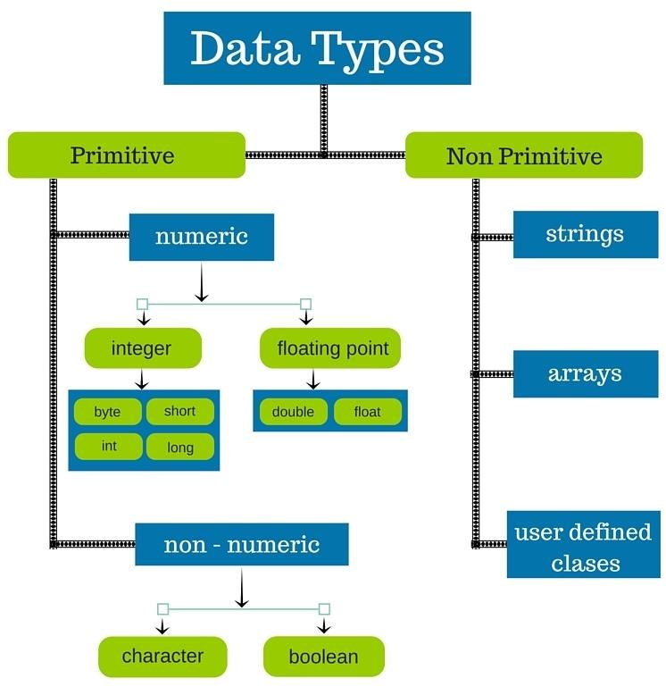

#### Data Types

Java Data types are classified into 2 type

* **Primitive Data Types:** A primitive data type is pre-defined by the programming language..
* **Non-Primitive Data Types:** These data types are not actually defined by the programming language but are created by the programmer.

**Example**

int − Used to store an integer value

char − Used to store a single character

 float − Used to store decimal numbers with single precision

string-Used to store a collection of char

1. Define JRE, JDK, and JVM and explain the execution process of Java program.
2. **JRE**: JAVA RUN TIME ENVIRONMENT is a software that java programs require to run correctly

**JDK**: JAVA DEVELOPMENT KIT is a distribution of java technology by Oracle Corporation ,it’s a development environment for building application and components using the java programming languages

## JVM:Java Virtual Machine (JVM) is a engine that provides runtime environment to drive the JavaCode or applications.

It converts Java bytecode into machines language. JVM is a part of Java Run Environment (JRE).

Java, being a platform-independent programming language, doesn't work on the one-step compilation. Instead, **it involves a two-step execution, first through an OS-independent compiler; and second, in a virtual machine (JVM) which is custom-built for every operating system**

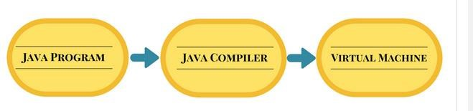

Source code byte code

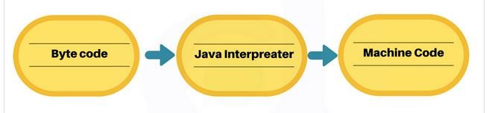

Virtual Machine Real Machine

4.Explain Scanner class in java with an example

import java.util.Scanner;

class Main {

public static void main(String[] args) {

Scanner myObj = new Scanner(System.in);

System.out.println("Enter name, age and salary:");

// String input

String name = myObj.nextLine();

// Numerical input

int age = myObj.nextInt();

double salary = myObj.nextDouble();

// Output input by user

System.out.println("Name: " + name);

System.out.println("Age: " + age);

System.out.println("Salary: " + salary);

}

}

output

5.Define Variable with example and list the rules to declare a variable name?

1. A Java variable is a piece of memory that can contain a data value. A variable thus has a data type. Data types are covered in more detail in the text on [**Java data types**.](http://tutorials.jenkov.com/java/data-types.html)

**Rules for naming variables:**

* They must not begin with a digit.
* Uppercase and Lowercase are distinct. This means that the variable Total is not the same as total or TOTAL.
* It should not be keyword.
* White spaces is not allowed.

Variables name can be of any length

There are three types of variables in Java:

* Local Variables
* Instance Variables
* Static Variables

**Local Variables**: A variable defined within a block

public class StudentDetails {

public void StudentAge()

{

int age = 0; age = age + 5;

System.out.println("Student age is : " + age);

}

public static void main(String args[])

{

StudentDetailsobj = new StudentDetails(); obj.StudentAge();

}

}

output

**Instance(Gloable) Variables**:

Instance variables are non-static variables and are declared in a class outside any method, constructor or block.

**Static Variables**:

* Static variables are also known as Class variables.
* These variables are declared similarly as instance variables, the difference is that static variables are declared using the static keyword within a class outside any method constructor or block.